**FACE DETECTION**

This project was done with the help of “open source computer vision library” the OpenCV.

**REQUIREMENTS:**

1. A computer system with webcam
2. Package of OpenCV python
3. Source code in python

**Uses of fake reconginition:**

1. Face Recongnition for access control: the best lock ever has finally arrived.personal devices,residences,vehicles.
2. Attendence tracking and control: modern technology we use in schools and collages.
3. Marketing: it is one of the business domains being discurpted by AI the most.
4. Banking : at long lost what can be refund to reliable authourization.

1.**Face Detection In Python**



* Open CV: C++, JAVA, PYTHON we can use in this.
* (Open source computer vision library) it is a library of a programming functions mainly aimed at real time computer vision originally developed in intel.
* Image Processing to operate image.

**WHAT IS HAAR CASCADE ?**

* It is an object detection algorithm used to identify faces in an image or a real time video algorithm used edge or live detection.

**Positive image:**

* Contains face image files.

**Negative Image:**

* Contains other than image files.
* Face Detection: finds only face in the image.
* Face Recogintion: name is generated by reconginition.

**BIOMETRICS FACE RECOGNTION:**

1. **Capturing**
2. **Extracting**
3. **Comparing**
4. **Hatching**

**Note:**

Face detection was invented in 2001 by **VIOLA JONES.**

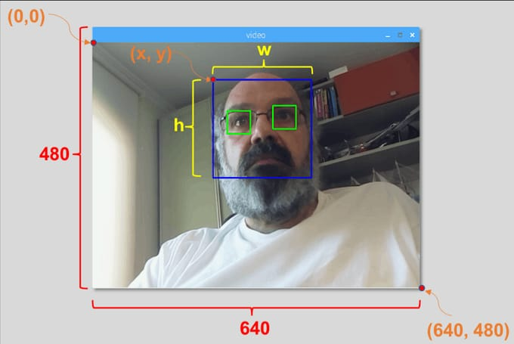

**WHAT IS COMPUTER VISION ?**

Computer vision is a process that involves capturing process and analyzing real-world image and video to allow machines to extract meaningful, contextual information from the physical world.

**WHAT IS OPEN CV ?**

OpenCV (open source computer vision library) is a library of programming functions mainly aimed at real time computer vision. Originally developed by intel. 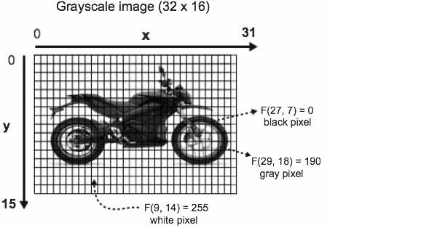

**CODE:**

**Import CV2**

**Import Os**

**Cascpath = os.path.dirname(cv2._file_)t”/data/haarcascade_frontalface_default.xml”**

**Facecascade=CV2.cascadeclassifer(cascpath)**

**Video_capture=CV2.videocapture(0)**

**Whiletrue:**

**ret,frames=video_capture.read()**

**gray=CV2.CVt color(frames,cv2.color_BGR2 GRAY)**

**Faces=facecascade.detectdetectmultiscale(gray,scalefactor=1.1,minsize=(30,30),flags=CV2.CASCADE_SCALE_IMAGE)**

**For(x,y,w,h) in faces:**

**CV2.rectangle(frames,(x,y),(x+w,y+h),(0,255,0),2)CV2.imshow(‘video’,frames)**

**If CV2.waitkey(1)&0XFF==ord(‘q’):**

**Break**

**video_capture.release()**

**CV2.destroyALLWindows()**